**Factual Q1, Definition of a Truss, factual**

**Q1 pre:** Which of the following best describes a truss? [source: https://quizizz.com/admin/quiz/652c89be3816241662d50a88/trusses-1?utm_source=chatgpt.com]

A. A bridge made from beams joined into triangular members

B. A structure comprised of members joined at their ends by friction pins

C. A structure comprised of members joined at their ends by friction-free pins

D. A structure comprised of beams joined in triangles, spanning between two supports

**Correct answer:** C

**Q1 post:** Which statement accurately defines a truss?  
 A. A framework of beams connected by rigid joints to form rectangles  
 B. An assembly of members connected at their ends by pinned joints, forming triangular units  
 C. A network of beams and columns supporting loads through fixed connections  
 D. A series of arches connected to span between supports  
 **Correct answer:** B

**Factual Q2, Types of Forces in Truss Members**

**Q2 pre:** Which types of internal forces are primarily carried by members in a simple truss?  
 A. Bending and torsion  
 B. Tension and compression  
 C. Shear and axial rotation  
 D. Buckling and shear  
 **Correct answer:** B

**Q2 post:** Which two internal forces are most commonly found in truss members?  
 A. Torsion and bending  
 B. Tension and compression  
 C. Shear and deflection  
 D. Axial force and shear stress  
 **Correct answer:** B

**Factual Q3, Definition of Zero-Force Members**

**Q3 pre:** In a truss structure, what is a zero-force member?  
 A. A member that carries no force under specific loading conditions  
 B. A member that always carries the maximum load  
 C. A member designed to carry shear forces only  
 D. A member that connects the truss to external supports  
 Correct answer: A

Q3 post:

In a truss structure, what is a zero-force member?

A. A member that carries no load under specific conditions but may enhance structural stability.​

B. A member that consistently bears minimal load regardless of external forces.​

C. A member designed to resist shear forces between connected elements.​

D. A member that primarily transfers torsional forces within the truss.​

Correct Answer: A

**Conceptual Q4, Apply understanding of truss determinacy using joints and members (M=2j-3)**

**Q4 pre:** A truss has 8 joints and 13 members. Is this truss statically determinate and internally stable?  
 A. Yes, it meets the condition for internal stability  
 B. No, it has too many joints  
 C. Yes, because all members are in triangles  
 D. No, it needs more supports to be stable  
 **Correct answer:** A

**Q4 post:** A truss contains 10 joints and 19 members. Is this truss statically determinate and internally stable?  
 A. No, it has more members than needed and is over-constrained  
 B. Yes, the number of members and joints satisfies the condition for stability  
 C. No, it requires additional zero-force members to be stable  
 D. Yes, as long as supports are placed at each joint  
 **Correct answer:** B

**Conceptual Q5, Recognizing when zero-force members are important**

**Q5 pre:** In which of the following situations would keeping a zero-force member in a truss be most justified?

A. The structure carries a constant, predictable load in a controlled environment  
 B. The structure may experience varying loads from different directions over time  
 C. The truss is small and intended for short-term use with minimal weight  
 D. The design prioritizes aesthetics over structural performance

**Correct answer:** B

**Q5 post:** In which of the following situations is the inclusion of zero-force members in a truss most critical?

A. A truss located in a region prone to frequent earthquakes.​  
 B. A truss used in a climate-controlled warehouse with stable conditions.​  
 C. A decorative truss installed in a residential interior.​  
 D. A temporary truss erected for a short-term event with minimal loads.​

**Correct answer:** A

**Conceptual Q6, Zero-force analysis**

**Q6 rule 1**

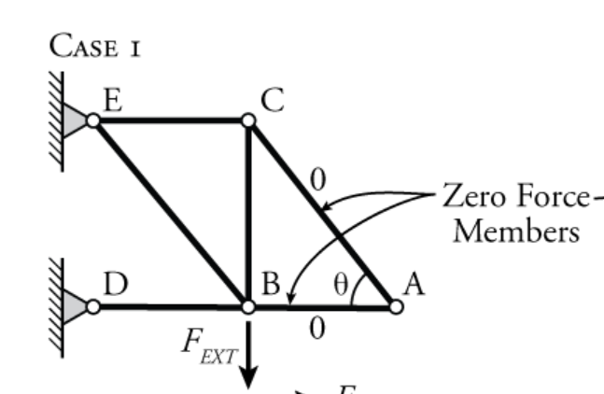

**Q6 rule 2**

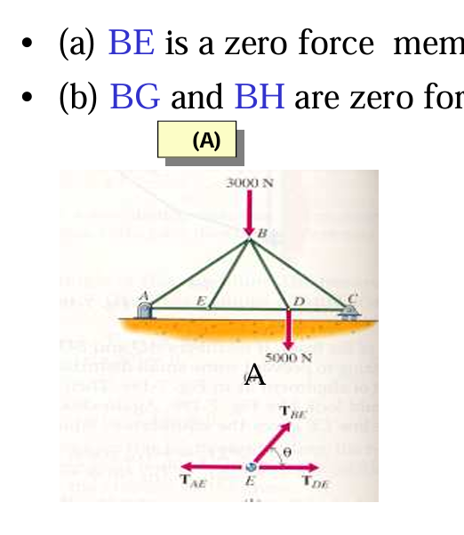

Backup

